eCMS MANUAL

TARIFF

Department of Revenue and Customs
Ministry of Finance

Table of Contents
1. Introduction 1
2. Logging in as Officer 1
3. Tariff 2
3.1. Consolidated HS View 2
3.2. Tax Type 2
3.3. CPC Group 3
3.4. Customs Procedure Code 4
3.5. Section 6
3.6. Chapter 7
3.7. Heading 7
3.8. Subheading 8
3.9. HS Code 9
3.10. Preferential Tariff 11

Introduction
With Tariff Management, harmonized codes for every type of goods are identified, defined and classified. Tariff rates that are to be imposed for the calculation of duties and tax fees are also determined. This module also maintains the preferential tariff for regional trade blocs and FTAs. The Customs Procedure Code (CPC) is also maintained and configured here. Certain CPC’s has duties and taxes suspended; this is configured in this module.

Tariff module is involved in all Regime flows. Refer to the regimes flows in the declaration processing SRS.

Tariff module codes like Chapter/Heading/Subheading/HS codes are used in Declaration, OGA, Valuation and System Admin modules.

Logging in as Officer

- The user needs to log into eCMS using the url: www.ecms.gov.bt
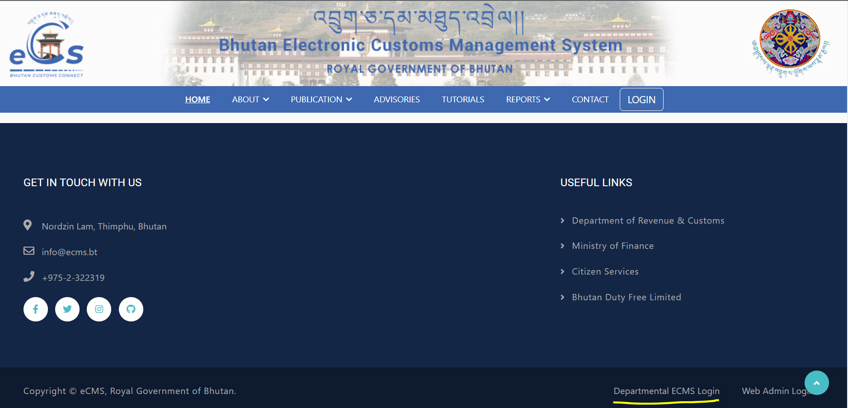
- Click on login menu and provide the required credentials to log in to the system:

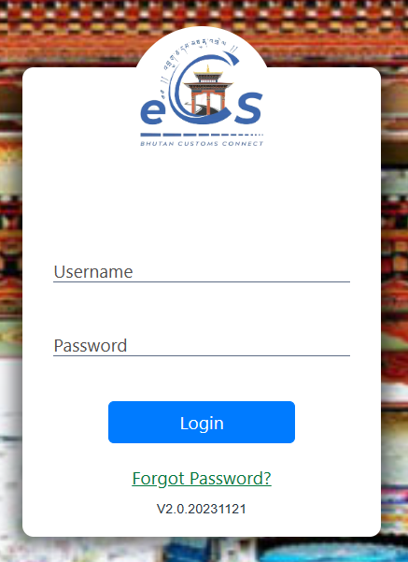

Tariff
- Click on the menu Tariff.

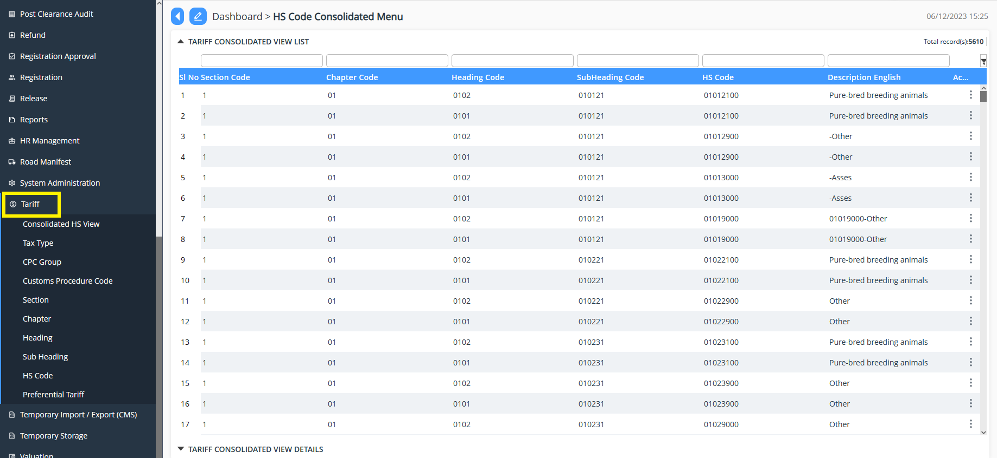

Consolidated HS View
- This module provides the view of HS that is there in the system.

Tax Type
- The module provides the list of pre-defined Tax type and one can add if required.
- To add: Click on 
- Provide the details under each tab:
  - TAX Type Details
    - Provide a unique code.
    - Provide the Name
    - Provide alternative name
    - Provide Tax Order number
    - Select Validity Date
    - Tick Active to enable the tax type
    - Save

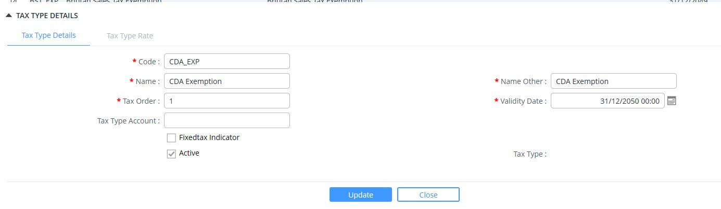

  - Tax Type Rate:
    - Select rate from the list
    - Select category
    - Select the From and To date
    - Tick the Active to enable the details.
    - Save

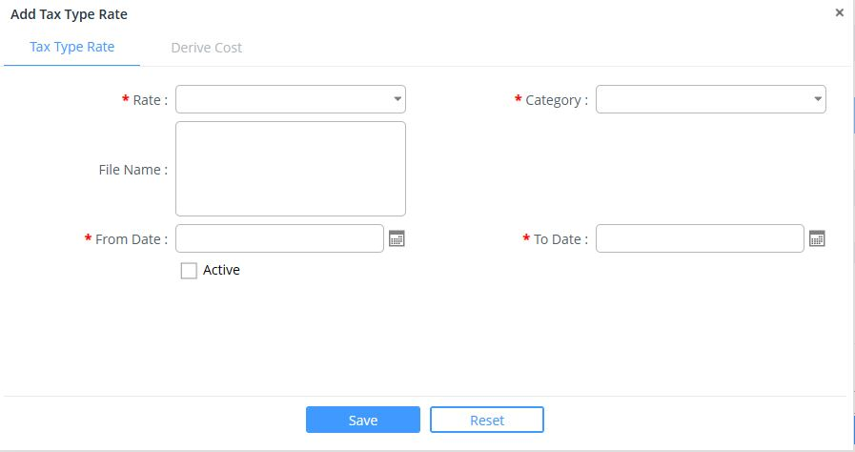

CPC Group
- The module provides the list of pre-defined CPC Group and one can add if required.
- To add: Click on 
- Provide the details under each tab:
  - Group details:
    - Select the Regime from dropdown
    - Provide CPC Group Code
    - Provide the description of the CPC Group
    - Provide additional information on the CPC group
    - Select Active (to enable the CPC Group)
    - Select Manifest required for declaration (if the CPC group required manifest)
    - Save
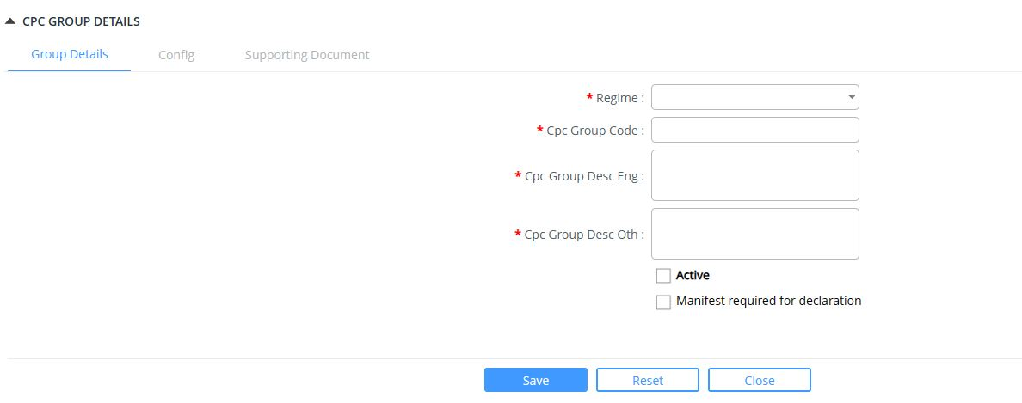
  - Config:
    - Select the CPC config from the dropdown list.
    - Save
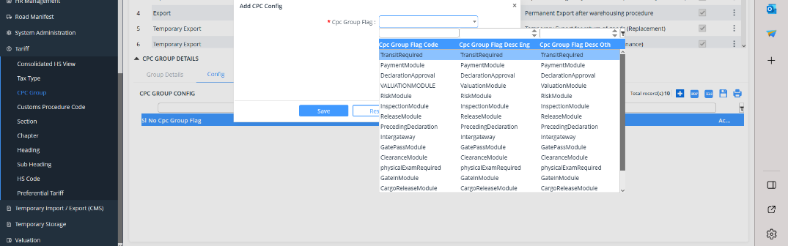
  - Supporting Documents:
    - Mandatory document required for the CPC can be added.
    - Click on add button
    - Select the document from the list of documents
    - Save
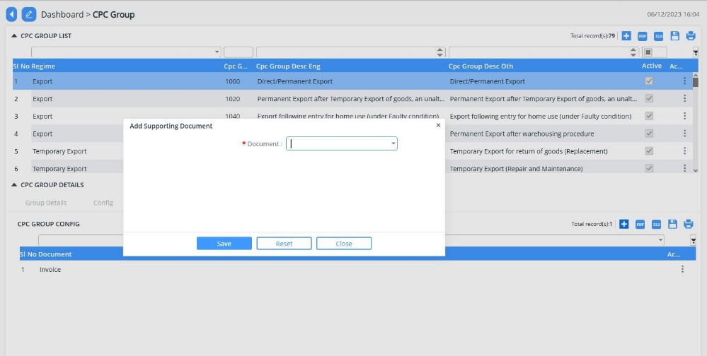

Customs Procedure Code
- The module provides the list of pre-defined Customs Procedure Code and one can add if required.
- To add: Click on 
- Provide the details under each tab:
  - CPC details:
    - Select the CPC Group
    - Provide CPC Code
    - Provide the description of the CPC
    - Provide additional information on the CPC
    - Select Active (to enable the CPC Group)
    - Provide remarks if any
    - Save
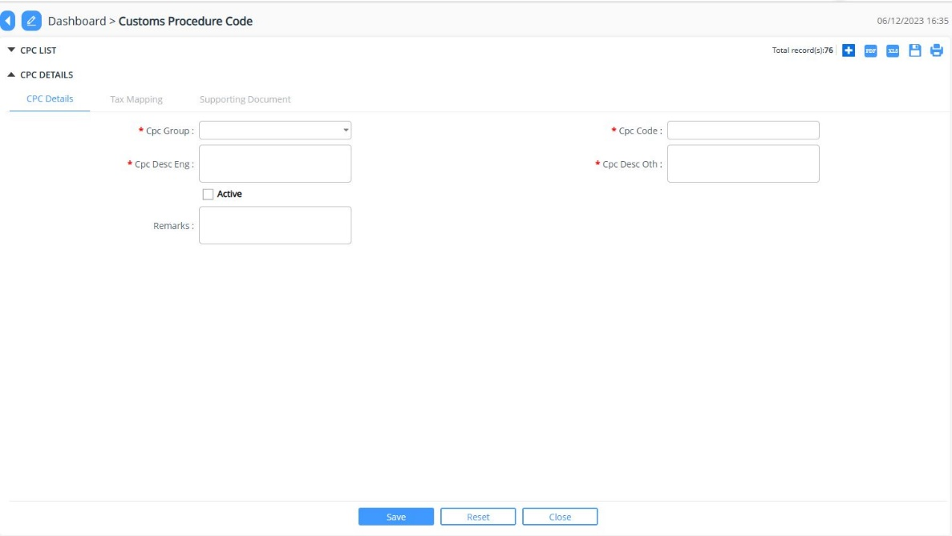

  - Tax Mapping
    - Select the Tax Type
    - Select the From and To date
    - Tick on not applicable tax
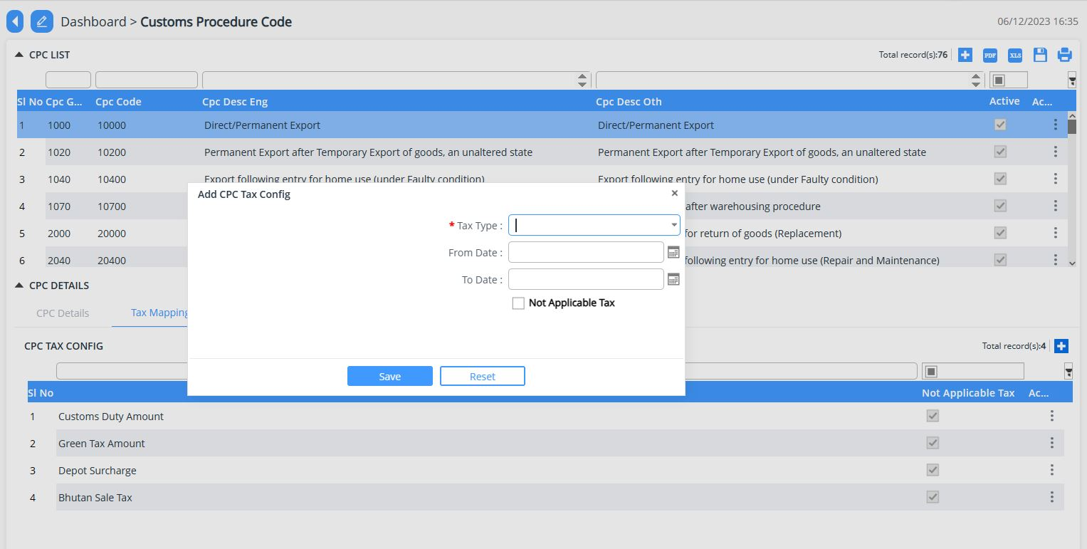
  - Supporting Documents:
    - Mandatory document required for the CPC can be added.
    - Click on add button
    - Select the document from the list of documents
    - Save
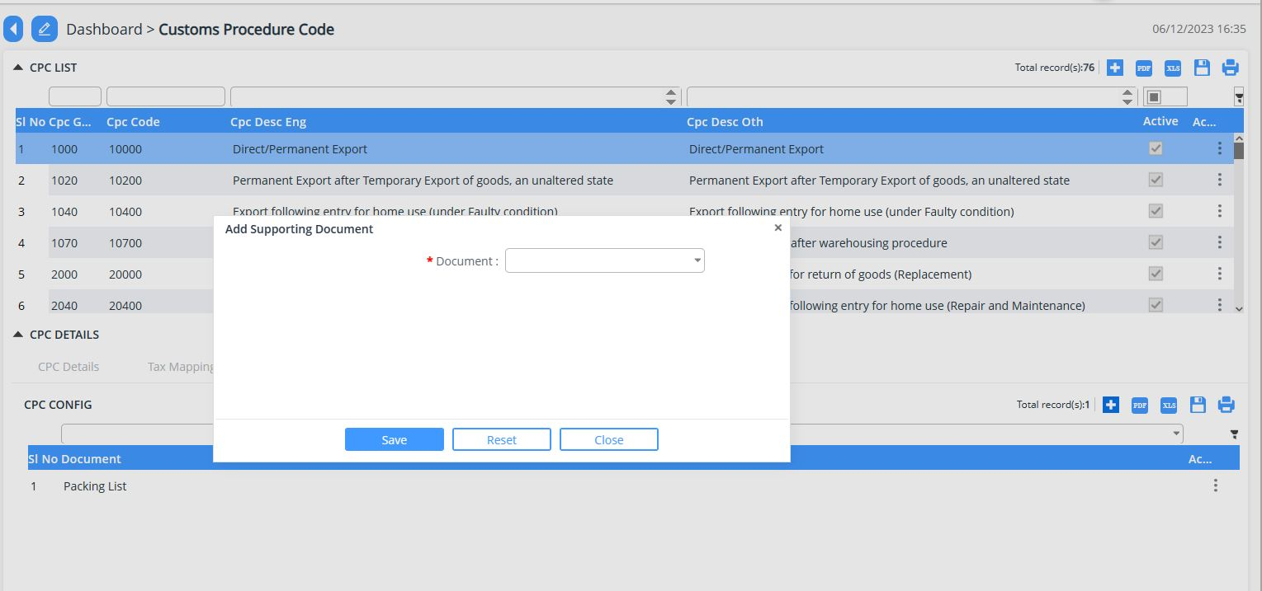

Section
- The module provides the list of pre-defined Section and one can add if required.
- To add: Click on 
- Provide the details under:
  - Provide the unique code to the section.
  - Provide the description.
  - Provide additional description.
  - Select Active (to enable the section)

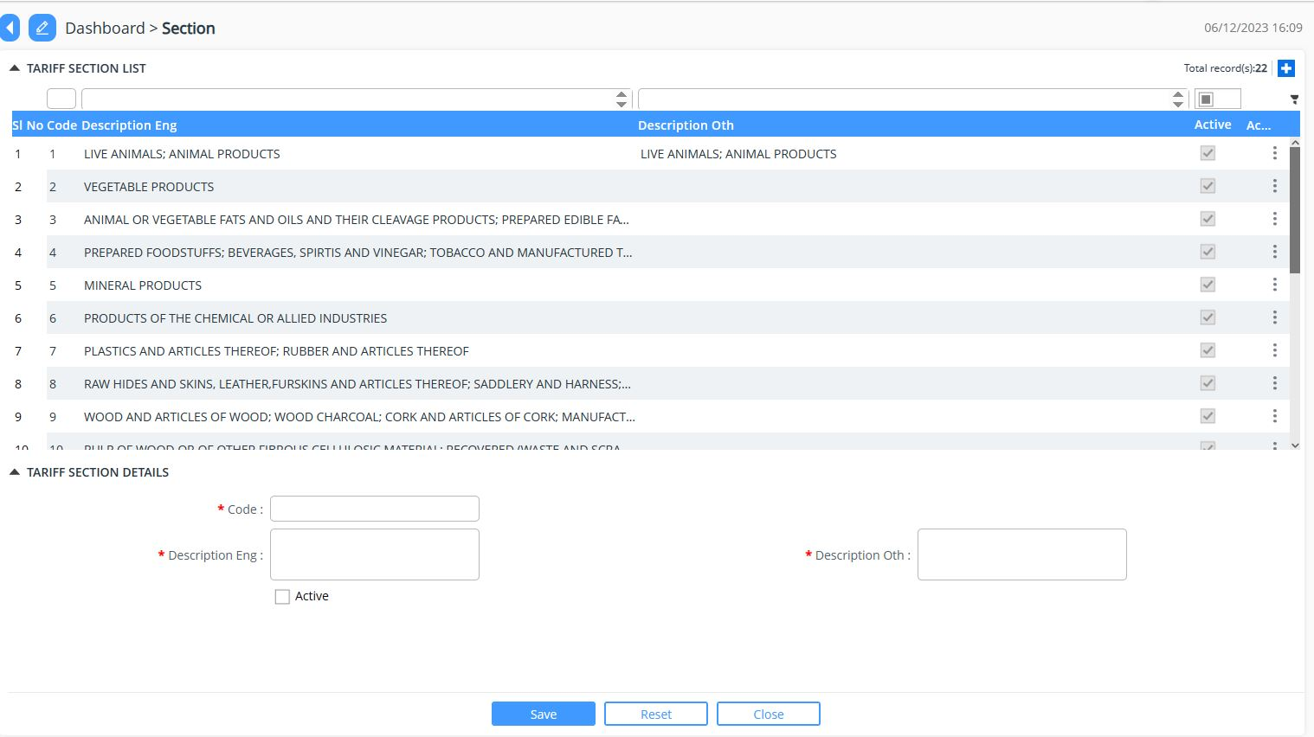

Chapter
- The module provides the list of pre-defined Chapter and one can add if required.
- To add: Click on 
- Provide the details under:
  - Select the Section from the dropdown list.
  - Provide unique code
  - Provide the description.
  - Provide additional description.
  - Select Active (to enable the section)
  - Save
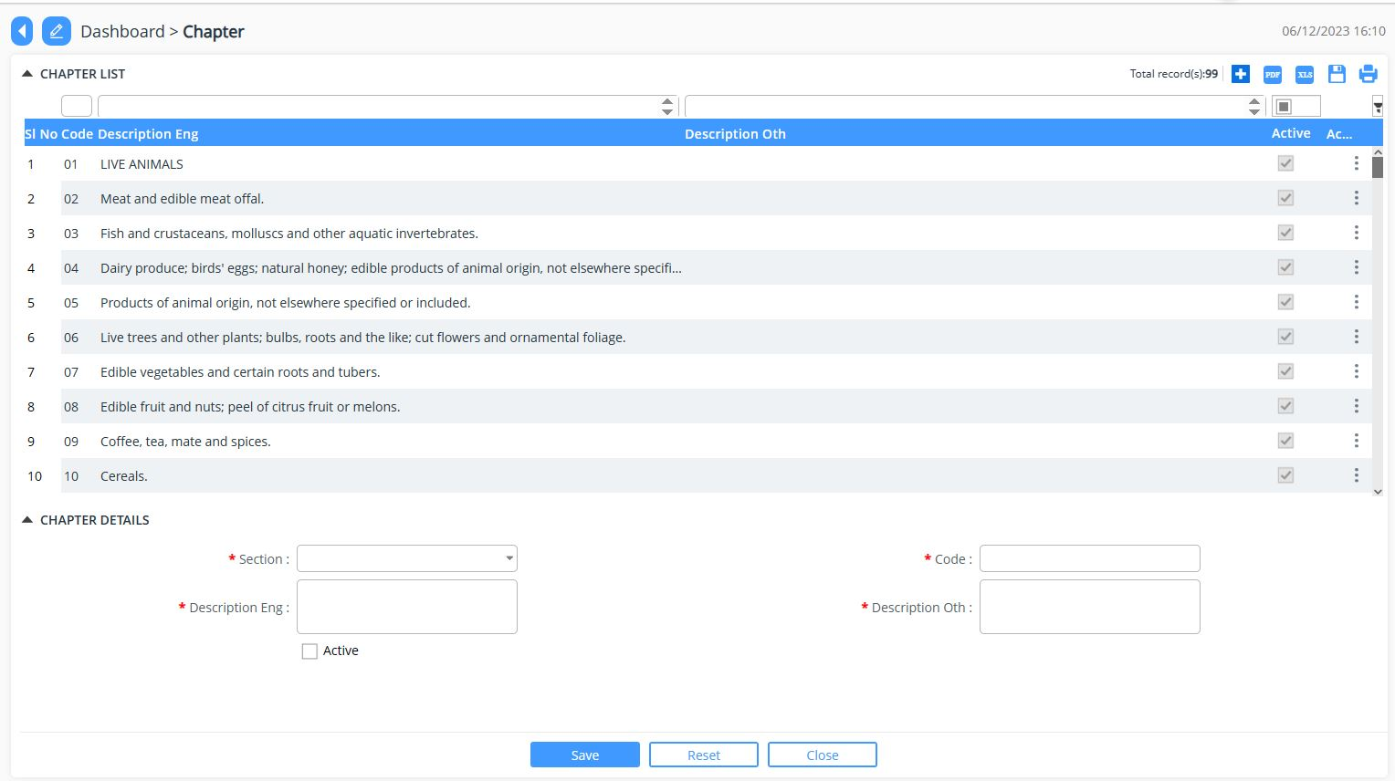

Heading
- The module provides the list of pre-defined Heading and one can add if required.
- To add: Click on 
- Provide the details under:
  - Select the Chapter from the dropdown list.
  - Provide unique code.
  - Provide the description.
  - Provide additional description.
  - Select Active (to enable the section)
  - Save

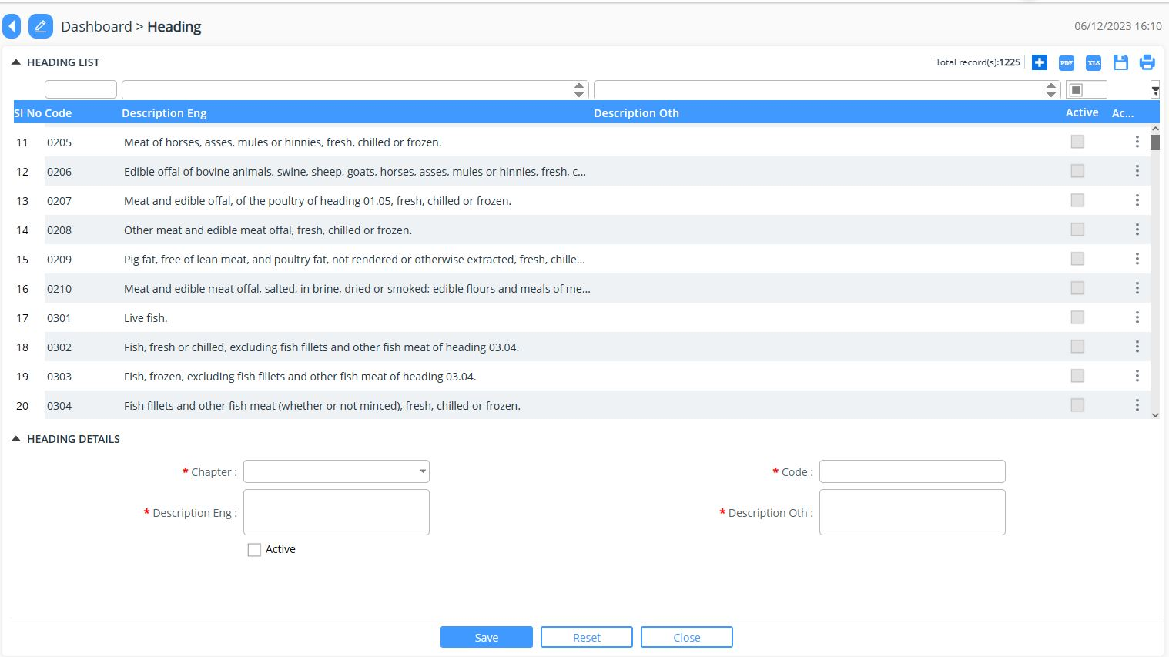

Subheading
- The module provides the list of pre-defined Heading and one can add if required.
- To add: Click on 
- Provide the details under:
  - Select the Heading from the dropdown list:
  - Provide unique code.
  - Provide the description.
  - Provide additional description.
  - Select Active (to enable the section)
  - Save

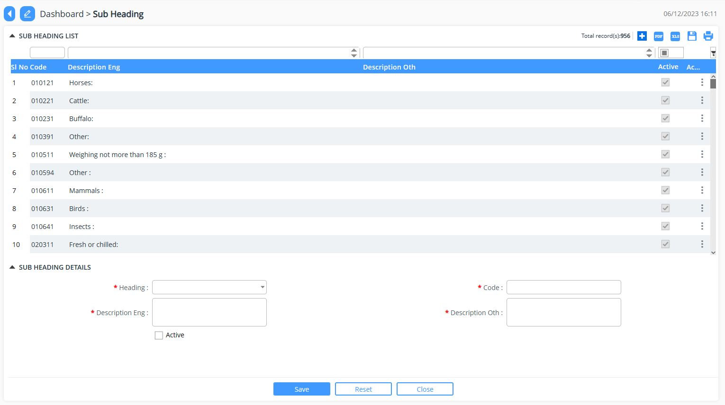

HS Code
- The module provides the list of pre-defined HS Code and one can add if required.
- To add: Click on 
- Provide the details under each tab:
  - HSCode:
    - Select subheading from the dropdown list
    - Provide unique code.
    - Provide the description.
    - Provide additional description.
    - Select the HS category
    - Select Active (to enable the section)
    - Save

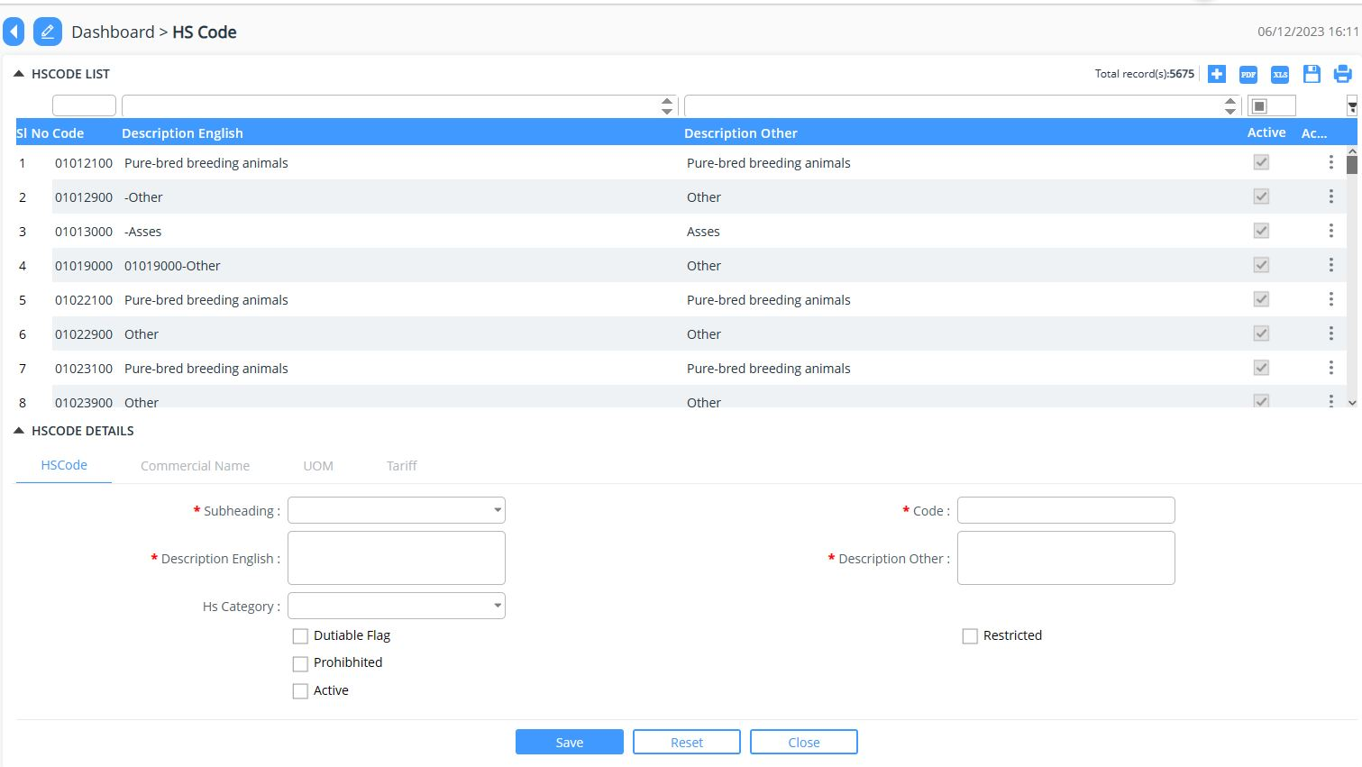
  - Commercial Name:
    - Provide the commercial name .
    - Provide additional name to the commercial name.
    - Select Active (to enable the section)
    - Save

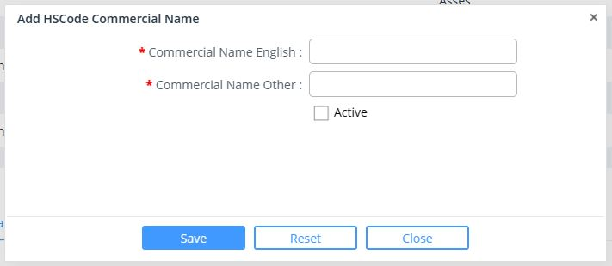

  - UOM
    - Provide the Unit of Measurement associated to the HS Code

  - Tariff:
    - Select the Tax from dropdown list
    - Select From and To date
    - Select Rate from the dropdown list
    - Select Active (to enable)
    - Select Has Additional taxed (if there is additional tax associated to the created HSCode)
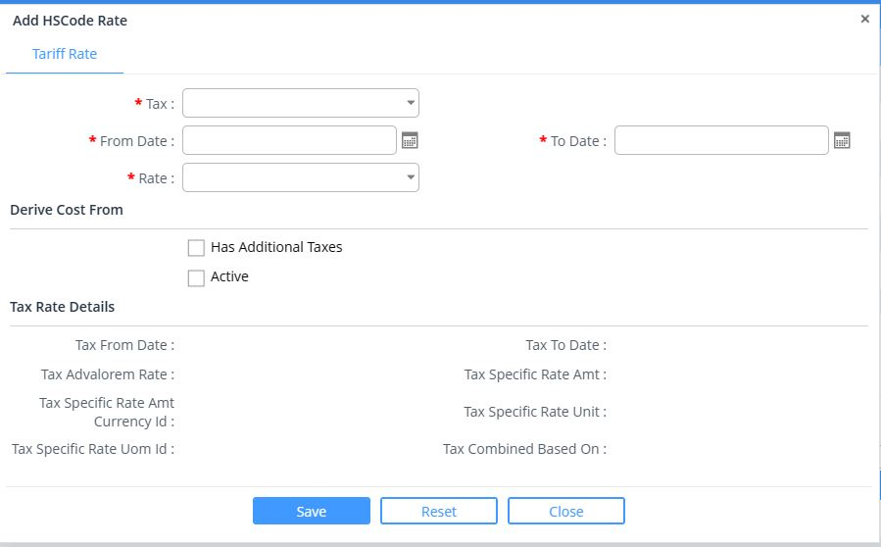

Preferential Tariff
- The module provides the list of pre-defined Preferential and one can add if required.
- To add: Click on 
- Provide the details under each tab:
  - Preferential Details:
    - Select the Type from the dropdown list
    - Provide Name
    - Provide other name
    - Provide Description to the tariff
    - Provide Additional description
    - Select Category from the dropdown list
    - Select Tax from the dropdown list
    - Select From and To date
    - Select Active (to enable the same)
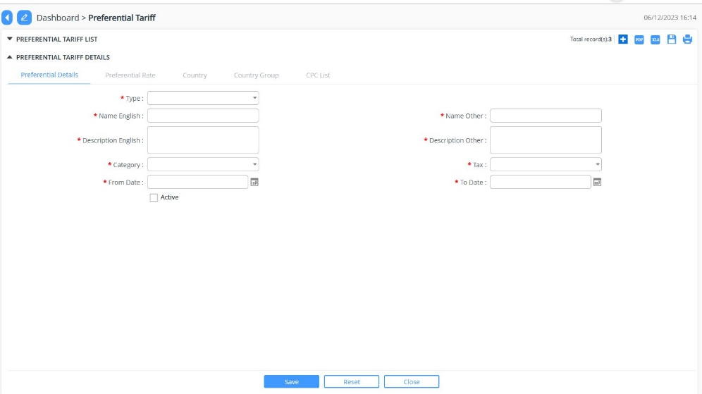

  - Preferential rate
    - Select Code type
    - Select rate
    - Select Active (to enable the same)
    - Save

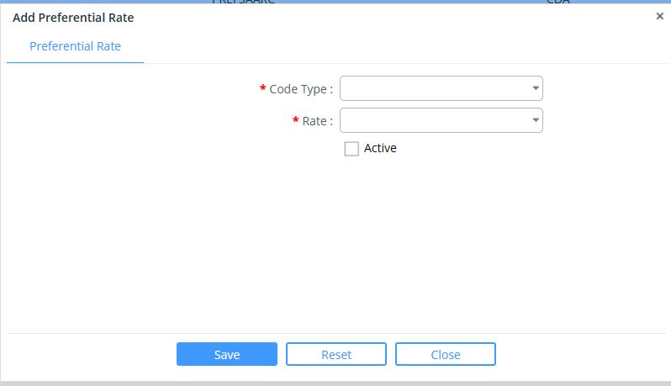

  - Country
    - Select the country code from the list
    - Save
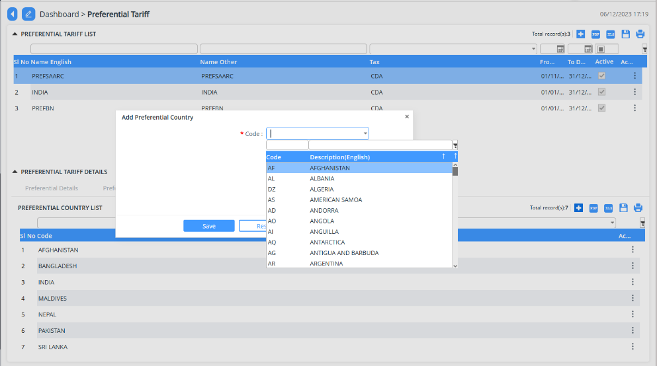

  - Country group
    - Select the country code from the list
    - Save
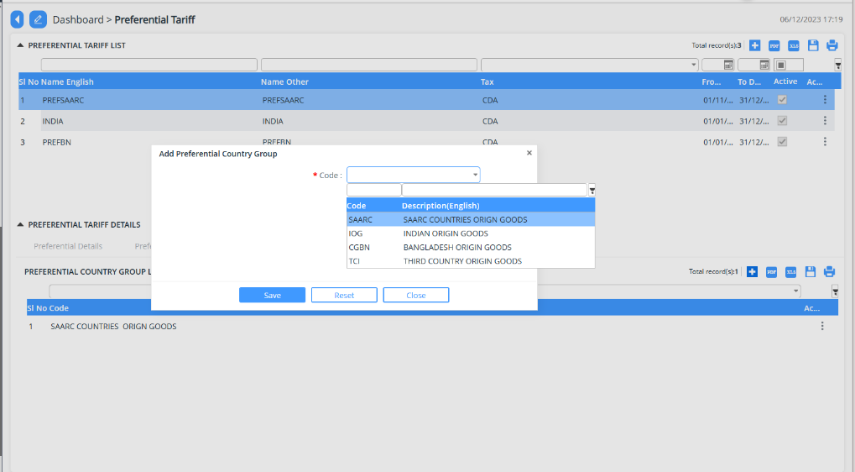

  - CPC List
    - Select the CPC from the list
    - Save
